BUG REPORT DOCUMENT
Project: Demo Website OrangeHRM
Module: Login
Reported By: Alfida Hari
Date: 01/02/2026

Bug 1
Field | Detail
Bug ID | BR-LOGIN-06
Title | Freeze saat login ulang setelah klik Back browser
Severity | High
Priority | Medium
Environment | Chrome, Windows 10
Steps to Reproduce | 1. Buka website OrangeHRM  2. Login dengan username: Admin dan password: admin123  3. Pastikan masuk ke dashboard  4. Klik tombol Back pada browser Chrome  5. Halaman login muncul kembali  6. Klik tombol Login
Actual Result | Tidak bisa masuk
Expected Result | Masuk dashboard
Screenshot | 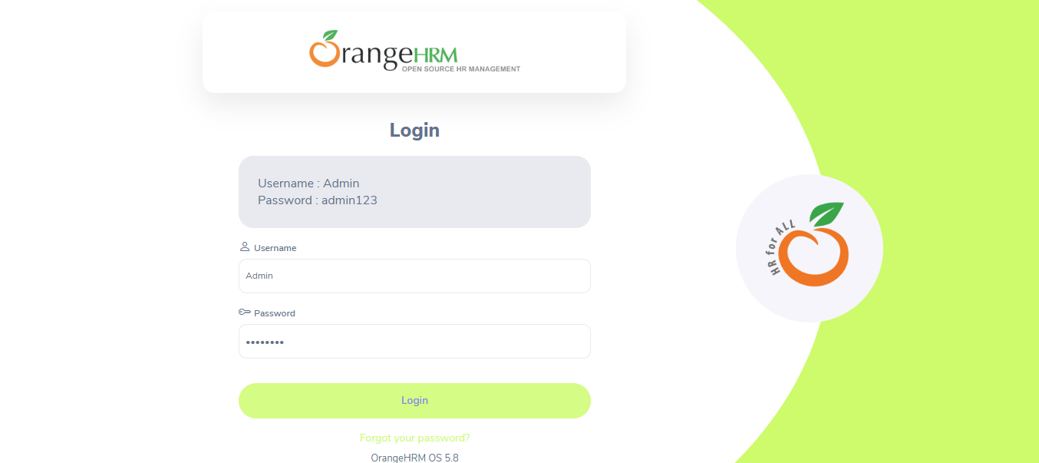
Status | Open

